Medcurity Network Team Inventory

Sponsor: Medcurity

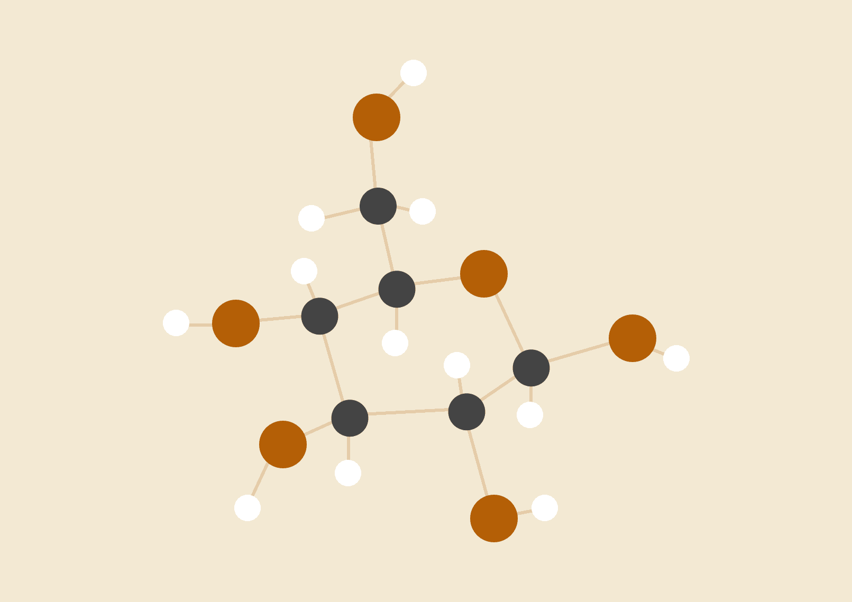

September 06, 2023

Advisor: Mike Mudge

Team Members: Brandon Huyck, Colleen Lemak, Artis Nateephaisan, Jack Nealon

Objective: To provide an overview of the team members of the Medcurity Network Team, including their skills, education, work experience, and interests.

Brandon Huyck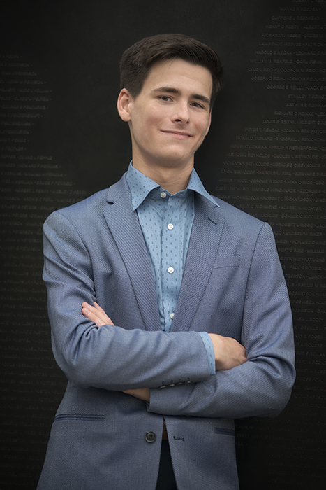

LinkedIn: linkedin.com/in/brandon-huyck

Skills

* Python, C/C++, Java, MySQL, R, Jupyter, Git, GitHub, Linux, Splunk, OOP, unit testing
* Problem solving, critical thinking, attention to detail, organization, big-picture thinking, brainstorming, teamwork, leadership, written and verbal communication, flexibility

Work Experience

* Starbucks, Software Engineering Intern in Tech Ops, Seattle, WA, May-August 2023
  + Workplace meetings, adaptability, solution design
  + Created a workflow using Microsoft Suite that increased automation and ease for team leadership, reducing fallibility of system; generated research report on technical transition for management; integrated into, and adapted, team culture.
* Mastercard, Technical Intern in BizOps, St. Louis, MO, June-August 2022
  + Big data, data analytics, data visualization
  + Created dashboards in Splunk that displayed the health of various applications using KPIs, determined the extent of impact of issues, and communicated to executives.
* Gonzaga University, Teaching Assistant, Spokane, WA, September 2022 – Present
  + Code review, explaining technical concepts
  + Data Structures and Algorithms, Introduction to Data Science, and Operating Systems

Education

* MyPL Interpreted Programming Language Project
  + Lexer, syntax parser, semantic checker, code generator, virtual machine, AST, visitor pattern
* GUI Yahtzee Application
  + OOP, Model-View-Controller, class and method design, SOLID, team project
* Computer Science Coursework
  + Databases, Computing Ethics, Theory of Computation, Programming Language Design, Machine Learning, Operating Systems, Computer Security, Introduction to Data Science
* Mathematics Coursework
  + Linear Algebra, Number Theory, Combinatorics, Statistics, Proofs, Calculus
* B.S. Computer Science, GPA 3.98, Gonzaga University, Spokane, WA, graduating May 2024

Interests

* Software Engineering, Testing, Databases, and Data Analysis
* Math tutor for K-12 students, foodie and cook, coffee nerd, card and board game player

Colleen Lemak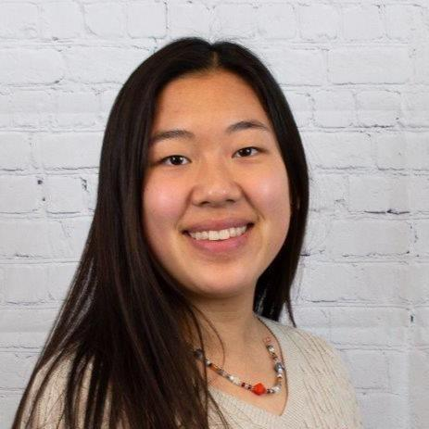

LinkedIn: linkedin.com/in/colleen-lemak/

Skills

* Proficiency in C++, Java, Python, R, MyPL, Kotlin, SQL, HTML.
* Consistent work-ethic and resilience
* Focused on a growth-mindset, a collaboratively oriented workplace, and a communicative atmosphere.
* Deeply values and strives for a diverse and inclusive work environment.

Publications

* Co-author of *IEEE Cyber Security and Resilience (CSR)* paper, 08/2023
  + *New Version, New Answer: Investigating Cybersecurity Static-Analysis Tool Findings*
  + [*https://ieeexplore.ieee.org/document/10224930*](https://ieeexplore.ieee.org/document/10224930)

Work Experience

* iD Tech Lead Instructor, 06/2023 to 08/2023

Lewis and Clark College – Portland, OR

* + Responsible for organizing and instructing computer science courses for 13-17 year olds and dispensing all medications necessary.
  + Courses include Artificial Intelligence & Machine Learning, Java Coding for Applications and Game Development, and Introduction to Python for Machine Learning.
  + A great opportunity to lead and engage with the next generation of programmers.
* NSF Cybersecurity Summer Researcher, 05/2022 to 08/2022

Montana State University Bozeman – Bozeman, MT

* + Produced analytic cybersecurity findings by programming scripts in Python and R.
  + Investigated static analysis tools, cwe_checker and cve-binary-tool, tracking their output consistency over time.
  + Dedicated extensive time to creating and presenting a research poster, in addition to conducting a thorough literature review prior.
  + Navigated GitHub for code efficiency and proper file management.
* Computer Science Teaching Assistant, 08/2021 to 12/2021

Gonzaga University – Spokane, WA

* + Provided tutoring aid to freshman and sophomore students in their computer science courses.
  + Graded exams and projects in course CPSC 122 with Dr. Paul De Palma.

Education

* Senior at Gonzaga University pursuing a BS Computer Science major, an Applied Mathematics minor, and a Software Security concentration – 3.62 GPA.
* Looking to build upon cybersecurity skills and develop tools and solutions in accordance with reliable security standards.
* Received high school diploma – 4.2 GPA.

Interests

* Beyond the computer, I love camping, hammocking, and enjoying nature.
* I am also passionate about mental and physical health, especially during gym or sporting workouts!

Artis Nateephaisan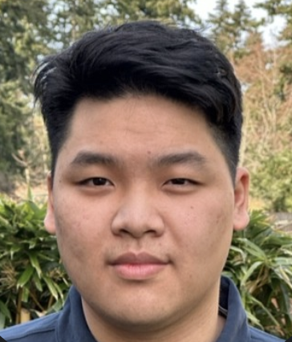

LinkedIn: <https://www.linkedin.com/in/artisnateephaisan/>

Skills:

* C, C++, Python, Java, SQL, OCaml, Assembly, Markdown
* Calculus 1, Calculus 2, Calculus 3, Ordinary Differential Equations, Discrete Math
* Eager learner, excited to learn new topics
* Works well individually or as a team

Work Experience

* No relevant work experience

Education:

* Shorewood High School
  + 3.6 GPA unweighted
  + Student of the Semester 2019
* Courses pertaining to this project
  + CPSC 341 Internet of Things
  + CPSC 348 Computer Security
  + CPSC 491 Software Engineering
* Ring Doorbell Project
  + Contributed to a Ring Doorbell Project in a GU CS course, utilized Firebase for cloud storage, interacted with Raspberry Pi, created scripts in Python, and created an Android app UI to interact with the IoT.
* Spotify Data Gatherer
  + Created a program in Python that could gather user’s Spotify data and display a summary of stats including favorite artists, listening time, and predicting which genres the user may enjoy.

Interests:

* Other than computer science, I enjoy reading, hanging out with family and friends, and shooting hoops.

John Nealon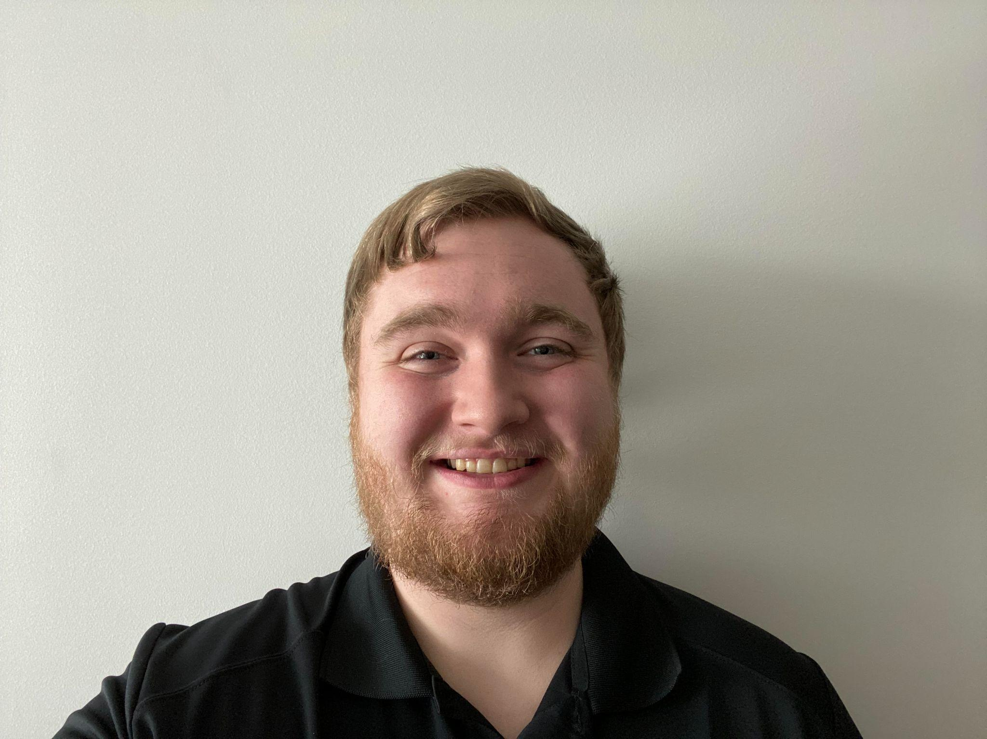

LinkedIn - <https://www.linkedin.com/in/jack-nealon/>

# Skills

A majority of my technical experience comes from my classes that I’ve taken while in school and I’ve acquired a number of skills to aid in my future career.

* **Programming** – Relevant experience with developing software written in C, C++, Java, Python, Netlogo, and x86 assembly languages.
* **Networking** – Experience working with networking technologies including Wi-Fi, ethernet, LAN/WAN and other connection systems.
* **Data Science** – Experience working with large scale data sets and produced analysis, optimization, and UI/UX software.
* **GitHub** – From my experiences throughout my college career, I have had a lot of experience with the systems of GitHub.

# Education

* High School: Silverton High School | Silverton, OR | 3.7 GPA | Honors Graduate
* University: Gonzaga University | Spokane, WA | Current Student
* B.A Computer Science and Computational Thinking - Biology Concentration
* Applicable courses pertaining to this project:
  + CS 341 – Internet of Things
  + CS 222 – Introduction to Data Science
  + CS 224 – Software Development
  + CS 223 – Data Structures
* Emphasis on technical application in biological industries

# Work Experience

* No relevant technical work experience.

# Interests

* In my personal life I am an avid chef who loves to study and create beautiful dishes with compelling flavors that create a memorable experience. I also read, write, watch movies and tv shows, and play the occasional video game. I am passionate about connecting technology with biology to develop optimized research strategies, secure information transfer, and UI/UX to improve communication.